***Creating and Managing Tables***

**Practice 9 Solutions**

1. Create the DEPT table based on the following table instance chart. Place the syntax in a script called lab9_1.sql, then execute the statement in the script to create the table. Confirm that the table is created.

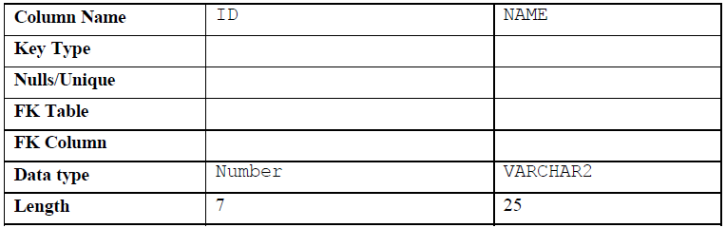

**CREATE TABLE dept**

**(id NUMBER(7),**

**name VARCHAR2(25));**

**DESCRIBE dept;**

2. Populate the DEPT table with data from the DEPARTMENTS table. Include only columns that

you need.

**INSERT INTO dept**

**SELECT department_id, department_name**

**FROM departments;**

3. Create the EMP table based on the following table instance chart. Place the syntax in a script called

lab9_3.sql, and then execute the statement in the script to create the table. Confirm that the table is

created.

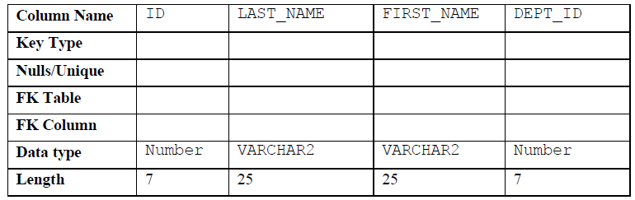

**CREATE TABLE emp**

**(id NUMBER(7),**

**last_name VARCHAR2(25),**

**first_name VARCHAR2(25),**

**dept_id NUMBER(7));**

**DESCRIBE emp;**

4. Modify the EMP table to allow for longer employee last names. Confirm your modification.

**ALTER TABLE emp**

**MODIFY (last_name VARCHAR2(50));**

**DESCRIBE emp;**

5. Confirm that both the DEPT and EMP tables are stored in the data dictionary. (**Hint:**

USER_TABLES);

**SELECT table_name**

**FROM user_tables**

**WHERE table_name IN ('DEPT', 'EMP');**

6. Create the EMPLOYEES2 table based on the structure of the EMPLOYEES table. Include only the

EMPLOYEE_ID, FIRST_NAME, LAST_NAME, SALARY, and DEPARTMENT_ID columns. Name

the columns in your new table ID, FIRST_NAME, LAST_NAME, SALARY , and DEPT_ID,

respectively.

**CREATE TABLE employees2 AS**

**SELECT employee_id id, first_name, last_name, salary,**

**department_id dept**_**id**

**FROM employees;**

7. Drop the EMP table.

**DROP TABLE emp;**

8. Rename the EMPLOYEES2 table to EMP.

**RENAME employees2 TO emp;**

9. Add a comment to the DEPT and EMP table definitions describing the tables. Confirm your additions in the data dictionary.

**COMMENT ON TABLE emp IS 'Employee Information';**

**COMMENT ON TABLE dept IS 'Department Information';**

**SELECT \***

**FROM user_tab_comments**

**WHERE table_name = 'DEPT'**

**OR table_name = 'EMP';**

10. Drop the FIRST_NAME column from the EMP table. Confirm your modification by checking the description of the table.

**ALTER TABLE emp**

**DROP COLUMN FIRST_NAME;**

**DESCRIBE emp**

11. In the EMP table, mark the DEPT_ID column in the EMP table as UNUSED. Confirm your

modification by checking the description of the table.

**ALTER TABLE emp**

**SET UNUSED (dept_id);**

**DESCRIBE emp;**

12. Drop all the UNUSED columns from the EMP table. Confirm your modification by checking the

description of the table.

**ALTER TABLE emp**

**DROP UNUSED COLUMNS;**

**DESCRIBE emp;**